EX.NO: 01 NUMPY

DATE: 16/02/2024

AIM:

To calculate the values for the mathematical formulas using NumPy library

INTEGRATED DEVELOPMENT ENVIRONMENT (IDE) REQUIRED:

JUPYTER NOTEBOOK

REQUIRED LIBRARIES FOR PYTHON:

Numpy

PROCEDURE:

1. Euclidean distance

Tho mathematical tormuEa tor calcu:ating tha Euclidean distance betwaon 2 paints in 20 space:

(Gl PI)2 + (Qa P2)2

PROGRAM:

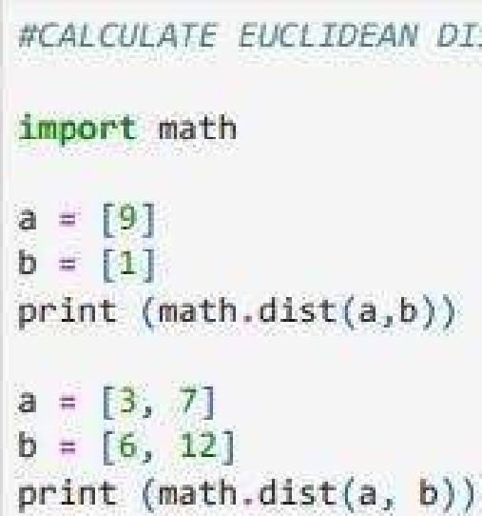

DISTANCE

OUTPUT:

5 .8309518948453

1. Dot Product



Cot 

PROGRAM:

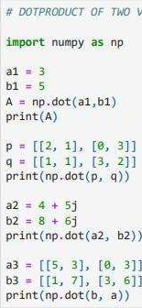VECTORS

OUTPUT:

15

102

1. Solving a System Of Linear Equations

A system of linear equations can be represented in matrix form as AX=B, whereA is the matrix of coefficients, X is the column vector of variables,

-1 and B is the column vector of solutions. To solve for X, we can use: X=A B assuming A is invertible.

PROGRAM:

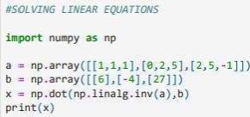

OUTPUT:

